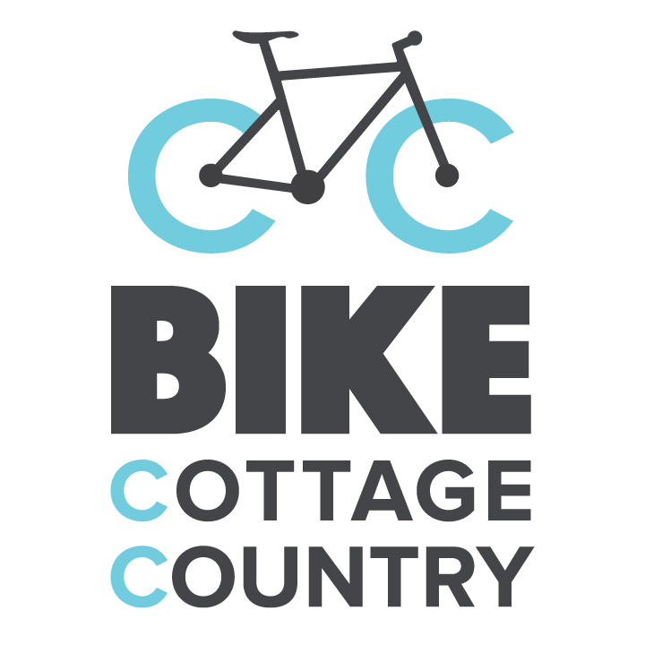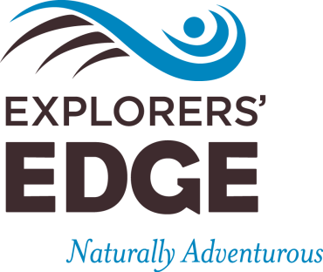

The Spring 2016 Cottage Country Bike Bucks Package Promotion and Partnership Agreement

Experience Provider

This AGREEMENT is between Explorers’ Edge and ____________________________________________, the “Experience Provider”.

In this Agreement
- “us” and “we” refer to Explorers’ Edge.
- “You” and “Your” refers to the Experience Provider who signs the Agreement.
- Bolded words are words that we have defined in this Agreement.

Purpose

Part of the Explorers’ Edge mandate is to help increase business for area tourism operators, including “Experience Providers” and “Accommodation Providers”. The Explorers’ Edge Spring 2016 Cottage Country Bike Bucks Package will do this by providing some incentives for your customers (who in this document we sometimes call ‘guests’) to book an experience with you. The incentives include a $50 Gas Card for the guest and 2 x $25 Experience Vouchers to be used by the customer “same as cash” and honored by Experience Providers. Your customers get these $50 worth of Vouchers by booking a two-night minimum consecutive stay at any regional Accommodation Provider (as listed on the Explorers’ Edge website business listings found here http://explorersedge.ca/stay/) by March 31, 2016 for the period between April 6, 2016 and June 30, 2016. Each Voucher is a “one time use” Voucher. (You are not involved with the redeeming of the Gas Card).

With your participation, you agree to honor the “Experience Vouchers”. We will reimburse you for the face value of the Experience Vouchers.

This purpose is included as the motivating force behind this Program and this Agreement, but it is not itself part of the Agreement. Please review terms on Page 2.

Terms

- As far as is possible, this Agreement is being drafted in ordinary language/plain English. The parties agree that any interpretation of this Agreement must consider context and a purposive approach to interpretation and a literal, strict interpretation is to be avoided.

- It is of critical importance to the success of this Program that you market this program. While Explorers’ Edge recommends a vigorous use of social media in addition to more traditional marketing and advertising choices, the choice of if, how, where and how much to market is always at your discretion and responsibility.

- As an Experience Provider you are considered a Tourism Operator in the Region. The criteria for defining what constitutes a tourism operator (as per the Explorers’ Edge Tourism Operator Relations Committee) is as follows:
- A business that operates within the borders of Explorers’ Edge and has a “storefront” here.
- A business that targets travelers: to bring them to the region; while they’re in the region; who live but also travel within this region.
- A business that accepts payment for services or product rendered.
- A business that is able to participate in packages or partnerships targeting tourists, though they may not choose to.

- Accommodation Providers are excluded from accepting Explorers’ Edge Cottage Country Bike Bucks vouchers from their own guests; they may accept Explorers’ Edge Cottage Country Bike Bucks vouchers from non-guests.

- You agree to accept the Experience Vouchers from the period April 6, 2016 through to June 30, 2016. When you sign up to participate in the program you will be sent a sample of these Vouchers. When you accept the Voucher, you agree to deduct the face value of the Experience Voucher from the price per person. Only one Voucher per person per guest experience is valid. You agree that any Guest using an Experience Voucher will be charged the same base amount as any other customer who is not using an Experience Voucher – the only difference in price will be the discount given by the Experience Voucher.

- When you receive the Experience Voucher from the Guest, you agree to verify that it has been signed by a regional Accommodation Provider. Submit the Experience Voucher to Explorers’ Edge at the address below. We agree to issue you a cheque within three weeks for the face value of the submitted and valid vouchers. You may submit your vouchers at any time, but they must be postmarked no later than July 31, 2016 for us to honor them.

- A guest who has any issue with the functioning of the Gas Card is to be told to contact James Murphy, Executive Director, at Explorers’ Edge.

- We reserve the right to terminate this program at any time without notice, but we will still be responsible for honoring any outstanding Gas Cards or Experience Vouchers.

- Either you or we may refer to this Agreement or to the other party’s participation in this program, in any and all promotional or other materials.

- This Agreement shall be governed by and construed in accordance with the laws of the Province of Ontario.

- Any of your questions regarding this Agreement shall be directed to James Murphy, Executive Director at Explorers’ Edge.

- This Agreement contains the entire agreement between us and you. There are no other agreements written or oral relating to this program. No modification of this Agreement shall be valid unless made in writing and signed by both us and you.

- If either we or you waive any duty of the other under this Agreement, it does not affect the remainder of the Agreement and it does not change any other duty required by this Agreement.

I have read and agree to the terms outlined in the Spring 2016 Cottage Country Bike Bucks Package Promotion and Partnership Agreement

Signed_____________________________________ Date__________________

Name and Title_____________________________________________________________________

Business Name_____________________________________________________________________

Business Address___________________________________________________________________

Contact Phone number________________________ Email_________________________________
(for duration of program)
To participate in this program, please return this agreement via email to Erin Smit at Explorers’ Edge no later than Tuesday, March 1, 2016.

Email: erin@explorersedge.ca
Fax: (705) 243-0392
Mail: 3-1 Taylor Road, Bracebridge ON, P1L 1S6
Once the agreement is received Explorers’ Edge will send you a jpg or png of the “Cottage Country Bike Bucks Package” logo for use in your marketing efforts.

